FULL NAME: **JUSAYAN, JUVELYN S.**

COURSE NAME: **INTERACTIVE PROGRAMMING AND TECHNOLOGIES 1**

COURSE CODE**: IT 263**

**HYPERTEXT PREPROCESSOR (PHP)**

**The History of PHP**

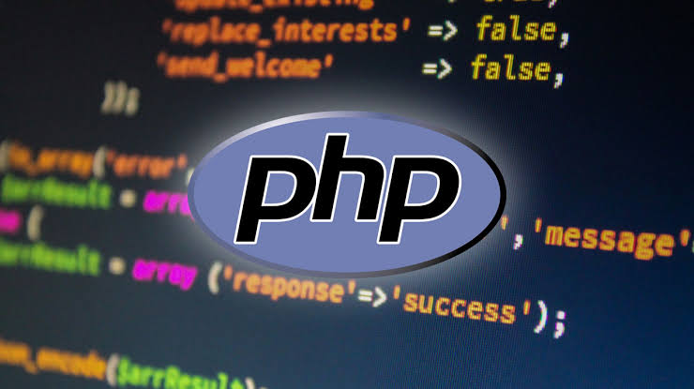 PHP is an "HTML-embedded scripting

language" primarily used for dynamic Web

applications. The first part of this definition

means that PHP code can be interspersed with

HTML, making it simple to generate dynamic pieces of Web pages on the fly. As a scripting language, PHP code requires the presence of the PHP processor. PHP code is normally run in plain-text scripts that will only run on PHP-enabled computers (conversely programming languages can create standalone binary executable files, a.k.a. programs). PHP takes most of its syntax from C, Java, and Perl. It is an open source technology and runs on most operating systems and with most Web servers. PHP was written in the C programming language by Rasmus Lerdorf in 1994 for use in monitoring his online resume and related personal information. For this reason, PHP originally stood for "Personal Home Page". Lerdorf combined PHP with his own Form Interpreter, releasing the combination publicly as PHP/FI (generally referred to as PHP 2.0) on June 8, 1995. Two programmers, Zeev Suraski and Andi Gutmans, rebuilt PHP's core, releasing the updated result as PHP/FI 2 in 1997. The acronym was formally changed to PHP: HyperText Preprocessor, at this time. (This is an example of a recursive acronym: where the acronym itself is in its own definition.) In 1998, PHP 3 was released, which was the first widely used version. PHP 4 was released in May 2000, with a new core, known as the Zend Engine 1.0. PHP 4 featured improved speed and reliability over PHP 3. In terms of features, PHP 4 added references, the Boolean type, COM support on Windows, output buffering, many new array functions, expanded object-oriented programming, inclusion of the PCRE library, and more. Maintenance releases of PHP 4 are still available, primarily for security updates.

**Definition**

Stands for "Hypertext Preprocessor." (It is a recursive acronym, if you can understand what that means.) PHP is an HTML-embedded Web scripting language. This means PHP code can be inserted into the HTML of a Web page. When a PHP page is accessed, the PHP code is read or "parsed" by the server the page resides on. The output from the PHP functions on the page are typically returned as HTML code, which can be read by the browser. Because the PHP code is transformed into HTML before the page is loaded, users cannot view the PHP code on a page. This make PHP pages secure enough to access databases and other secure information.A lot of the syntax of PHP is borrowed from other languages such as C, Java and Perl. However, PHP has a number of unique features and specific functions as well. The goal of the language is to allow Web developers to write dynamically generated pages quickly and easily. PHP is also great for creating database-driven Web sites.

**Summary**

In summary, PHP has many advantages, and those listed here are just some of the reasons for the success of PHP. Many people will offer their own reasons for using PHP - and this fact alone is testament to the power

and flexibility of PHP.Now that we know a little about The History of PHP and have an overview of how it works we can start looking at how to develop PHP based web sites, beginning with Creating a Simple PHP Script.